# Maths and Tech assignment

## What is post processing

Postprocessing is the editing of data captured by a camera. Therefore, postprocessing is popular technique within the films and games industry.

## Describe generally the use of post-processing in a graphics application

Snapchat, Instagram, Facebook all have the capabilities to give their users access to post processing effects with the use of user’s phone camera. The technique is referred to as image processing which is the manipulation of each individual pixel within an image so basically just post processing. They use image processing to locate a person’s face, (I’ve not fully looked into the how they determine a person’s face within an image but if I was to guess they probably look for determining features like eyes, nose, mouth and so on). After locating a user’s face, filters can be applied to manipulate the pixels on the image for example you could warp your face to make yourself look weird.

Films use post processing or also known as postproduction to edit and add elements to a film, this will involve graphical applications like photoshop to enhances and edit images.

<https://medium.com/cracking-the-data-science-interview/snapchats-filters-how-computer-vision-recognizes-your-face-9907d6904b91>

Video games are graphical applications that use postprocess effects for things such as screen transitions, god rays, fog, rain drops… this is just a few examples of what can be accomplished with this technique. These effects can help immerse the player for example seeing water run down a window just makes the gameplay feel more real.

## Explain the specific techniques used for your post-processing effects

Texture passing

Displacement mapping or height mapping is used to tell the shader how to manipulate the pixels this Is usually done with a timer that ranges from 0 to 1, so the effect is slowly applied. The burn process uses a height map which tells the shader what pixels need to be manipulate and which don’t need to be, depending on the timer and the current height.

## Sin wave

???Having a timer and using sin wave you can create a way to

## Colour manipulation

I use colour manipulation for the Tint, Grey noise, Invert and Tv processes. So, this technique just means I change the colour of the pixel within the post process shader. For example, the grey noise pixels need to be averaged to look grey this means for each pixel the RGB values are added together and divided by 3.

## Brightness manipulation

To add bloom to the scene you need to render the lights in the scene and turn everything else in the scene to black. To figure out what is a light and what isn’t you would look for the brightest pixels in the scene and any pixels with a brightness of 0.7 or more would be considered a light and would have the bloom effect applied to it.

## Pin Ponging

Pin ponging is a post process technique it uses two textures the reason for this is because you can’t render two effects to the same render target you have to use one texture as the shader resource and the other one as the render target. Otherwise you would just end up with one effect being the effect that is last on the cue. Why is it called ping ponging? The reason it’s called ping ponging is because once you render an effect to a texture that texture must trade places to with the second, the texture will trade places every time a new effect is passed therefore going back and forth i.e. ping ponging. So, one textures is the render target and one is the shader resources and they will switch position every pass of a new effect until the list of effects is empty.

# Discuss improvements or extensions you could make.

## Bloom improvements

To create a post process effect, you must render scene to a texture then send that texture through multiple passes of different postprocess shaders to give the texture different effects. but in many cases the effects are not worth it or complicated effects create performance issues. For example, bloom requires 4 passes of the scene texture to create the effect, first one to extract all the light, second to blur the extracted light horizontally, third to blur the extracted light vertically and lastly combine the blurred light texture with the original scene. A less expensive way to create bloom would be to create a bloom map by using a glossiness map a glossiness map defines the specular highlights per pixel to determine strength and size of the glare of when a light hits it also known as a specular power using this map you can create a fake bloom effect. The advantage of this would be performance the trade-off is a lower quality effect, but most users will not notice the difference.

The addition to of lens flare to the bloom effect would also improve the effect, making it more believable.

## Blur Improvements

Gaussian blur can be improved by using linear sampling instead of point sampling. Linear sampling will grab a collection of pixels from a texture instead of one pixel therefore the process is able to blur multiple pixels every iteration instead of a single pixel resulting in a stronger blur. This method will have the same effect of having multiple point sampling gaussian blurs running on the same image therefore reducing the number of passes.

## Light Beams

The light beams as I like to call them are my attempt of god rays. The way I did this is like the bloom effect but with an extra pass to sample the light texture and move the texture closer and closer toward the camera. It needs improving, the way I would do this is to first create an inclusion pre-pass which is a texture that renders all objects in the scene black and the areas the light can pass through red, you would also require a few if statement to check to see if the object is in front or behind the light source. Then using this new texture I would sample it similar to how I did mine but I would sample it in the direction of the light(this is mainly done with Sun light / directional light, I was using point lights in my example). This will result in a believable god ray / volumetric light scattering.

## Depth of field

Require a few improvements the lights in the scene use additive blending when they are rendered to the scene to blend their models with other areas of the scene, without this there is just a black square with a light in the middle. So, when I removed the background of the scene according to the adjustable depth value the lights had no background to blend with resulting in a black square around each of the lights. I also thought about how I would fix this and if I did the lights would still have issues.

The depth of field that I implemented doesn’t use the circle of confusion or COC this would be an future improvement to the effect.

<https://community.arm.com/developer/tools-software/graphics/b/blog/posts/post-processing-effects-on-mobile-optimization-and-alternatives>

# Basic Requirements

I achieved everything required for the basic requirements

# Advanced Requirements

## Bloom

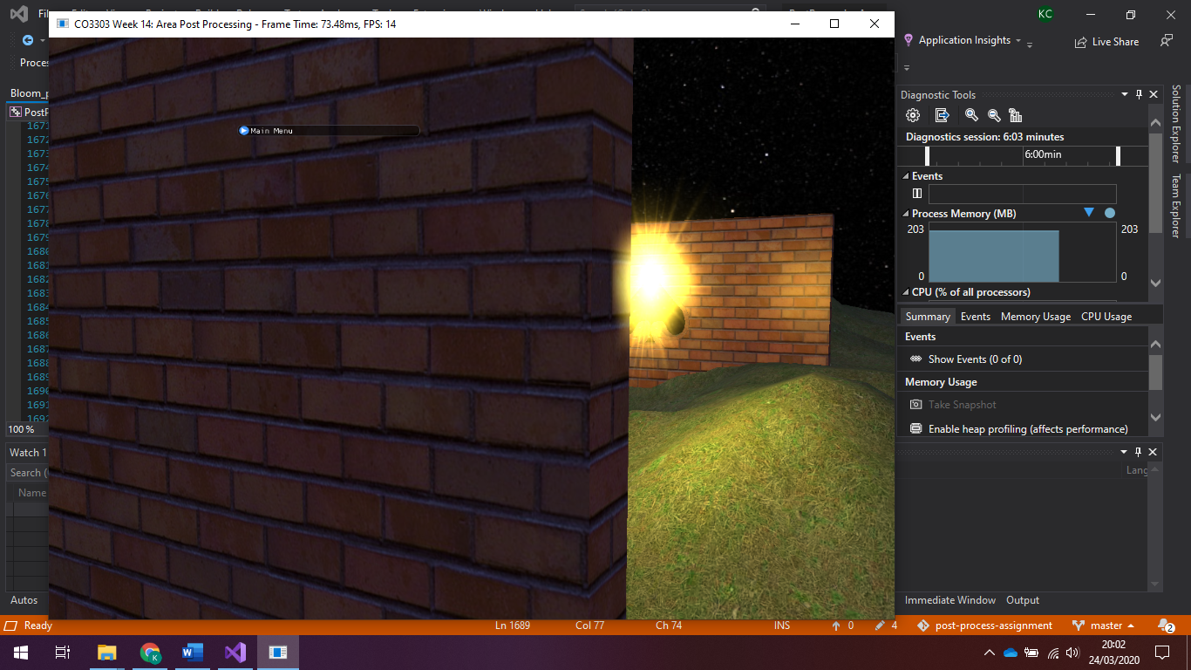Bloom Is created by filtering out all the bright pixels in a texture blurring them then adding them back to the original scene. This will cause the lights to get bigger and brighter due to them being blurred. As you can see from the image on the right the light bleeds into the objects. This was a difficult process trying to figure out how to make a copy of the scene and when to make a copy. To make this effect work with other effects I had to make the copy of the scene at a correct time others wise you could lose some of the other effects for example if you made a copy of the scene before applying the post process effects the image would lose all the effects applied before the bloom. The only thing I didn’t add to the bloom was lens flare.

## Gaussian Blur

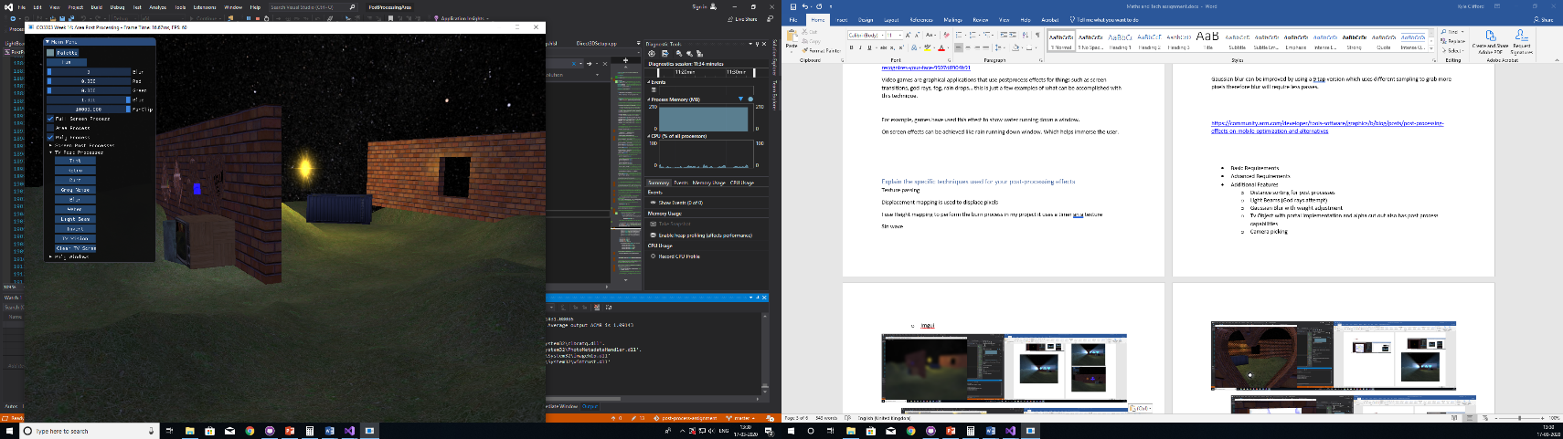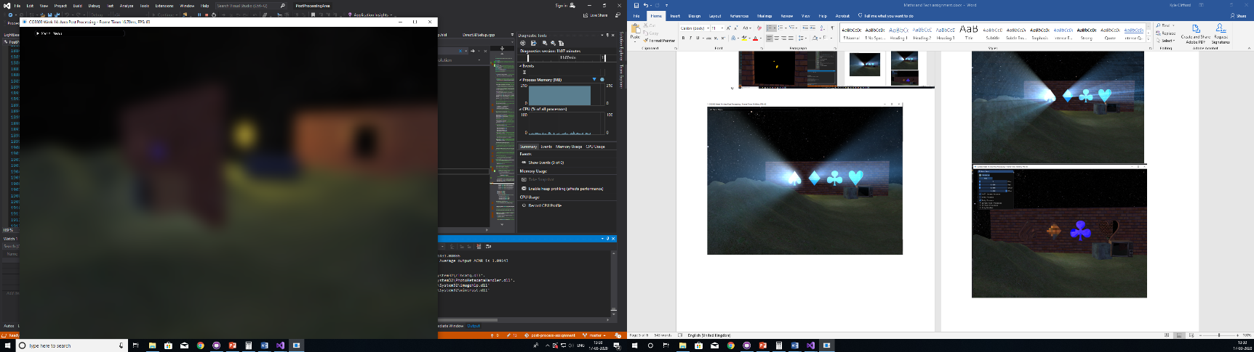

Gaussian blur is achieved by grabbing pixels from different areas of the image and adding them to the current pixel. This requires an offset and weights. Weights also known as normal distribution or gaussian kernel is a grid of numbers that all add up to equal 1 usually. Weights tell the blur how much colour it needs to sample from the given pixel and the offsets just determine what pixel to look at.

The weights are created in real time and can be adjusted using the slider on the GUI labelled Blur.

## Retro

## Depth of Field

* Additional Features
  + Distance sorting for post processes
  + Light Beams (God rays attempt)
  + Gaussian Blur with weight adjustment
  + Tv Object with portal implementation and alpha cut out also has post process capabilities
  + Camera picking
  + Imgui

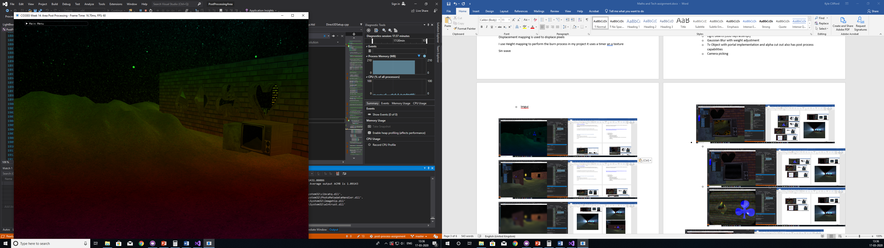

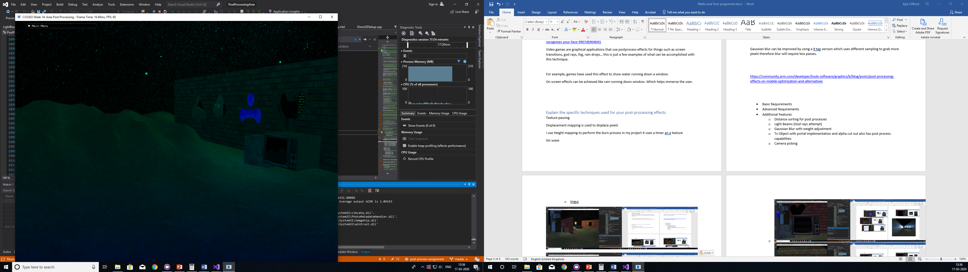

* 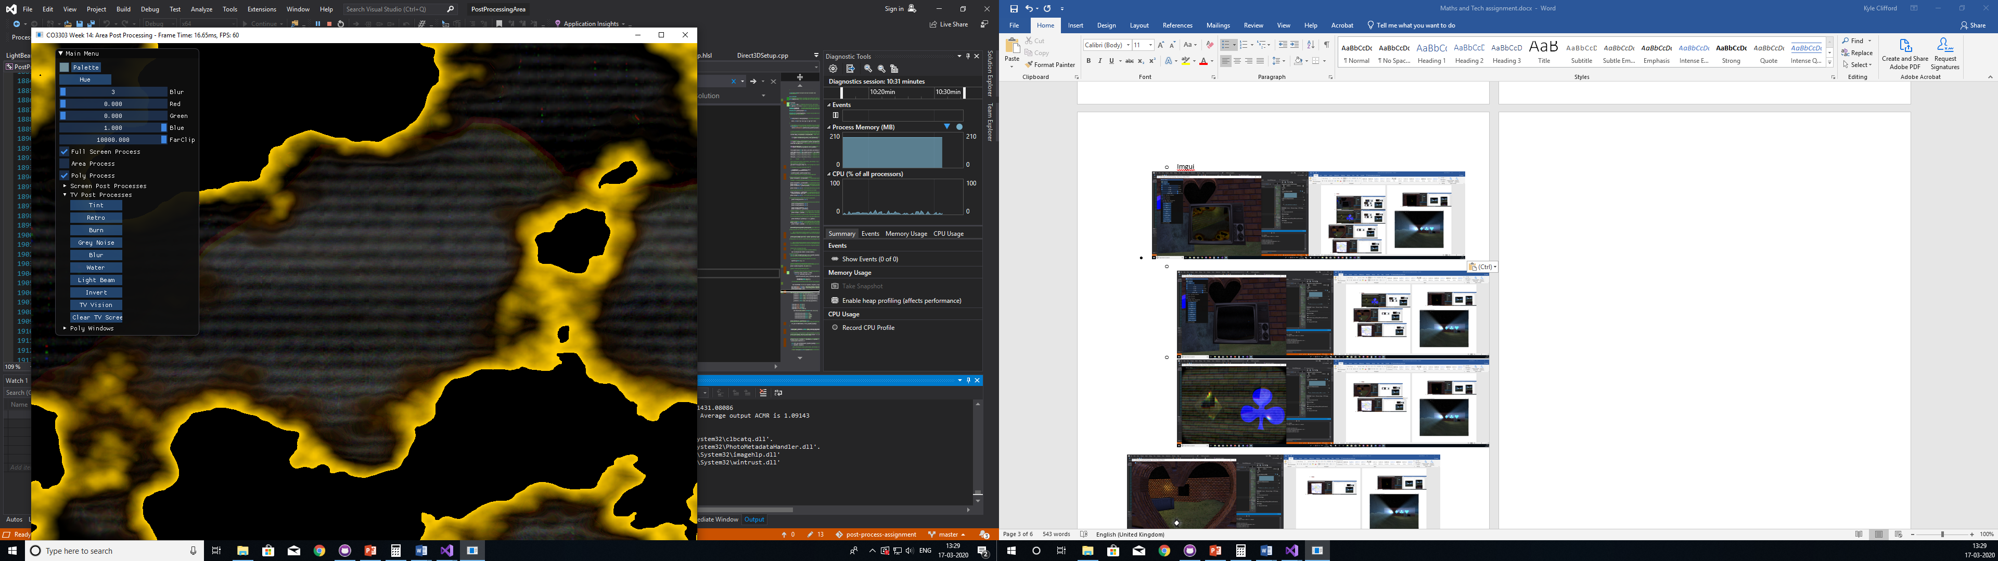
* 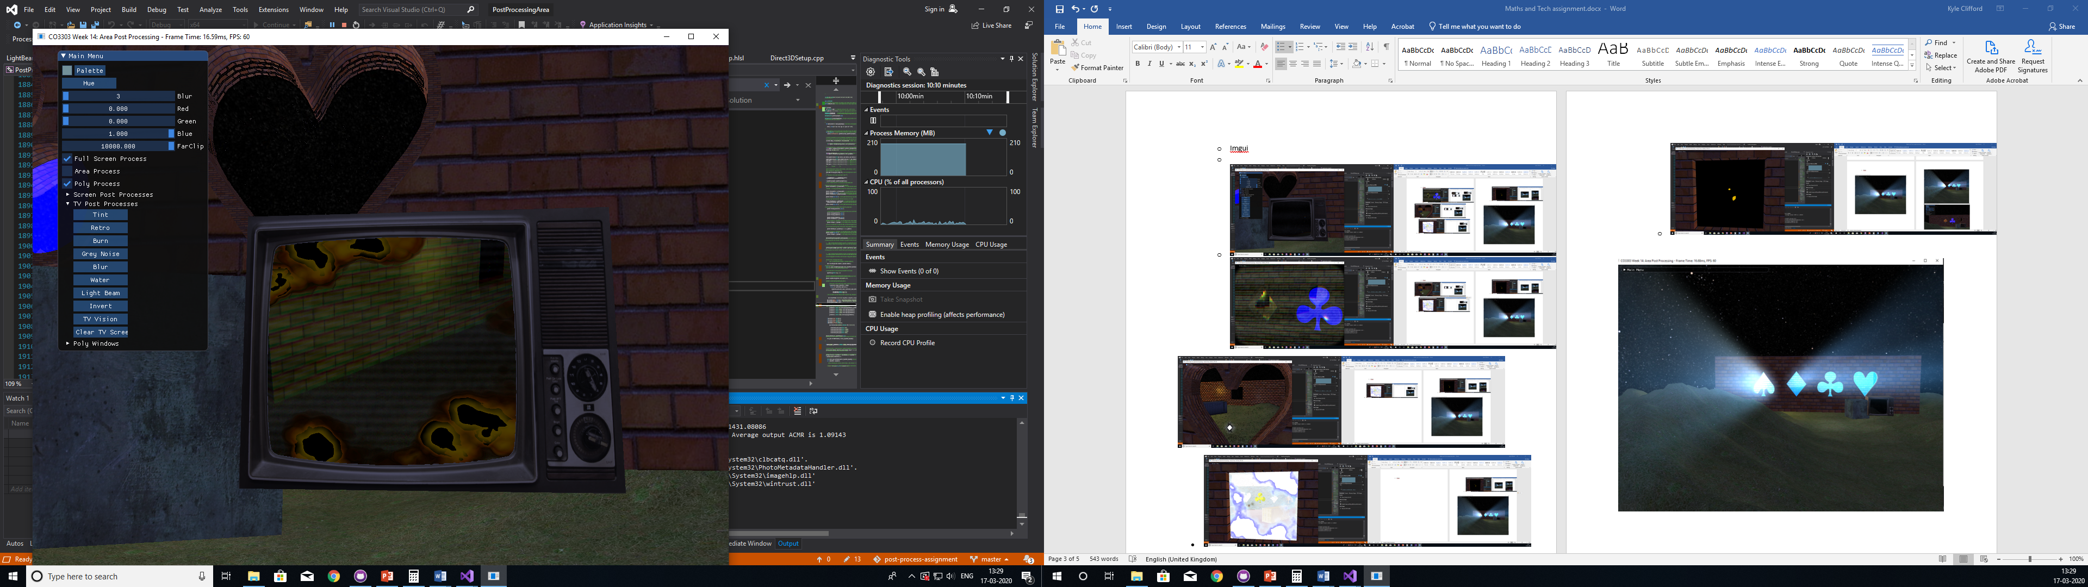
  + 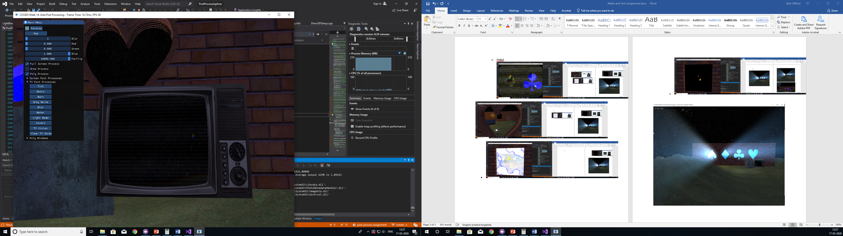
  + 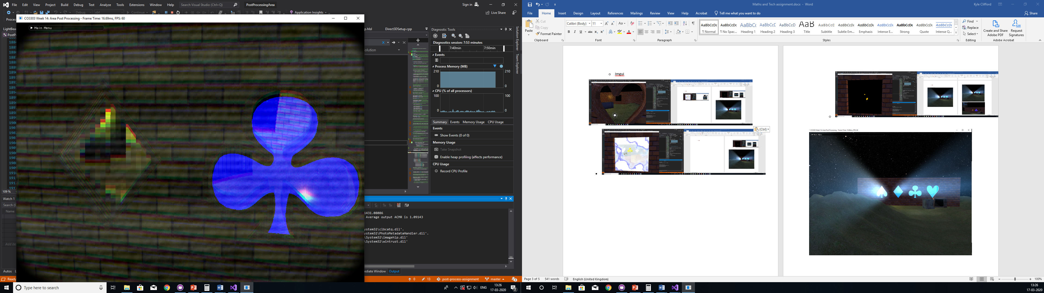

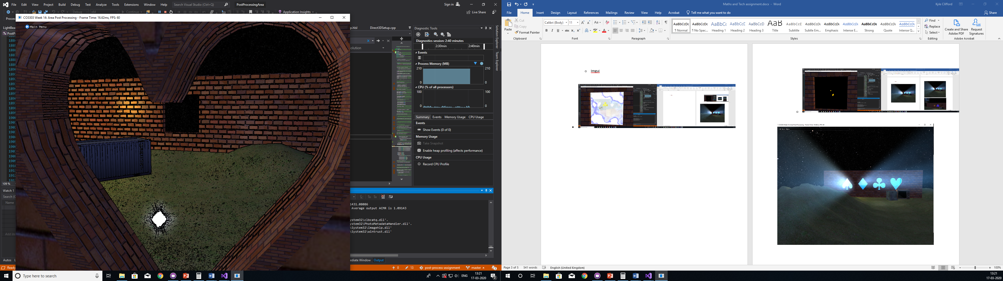

* 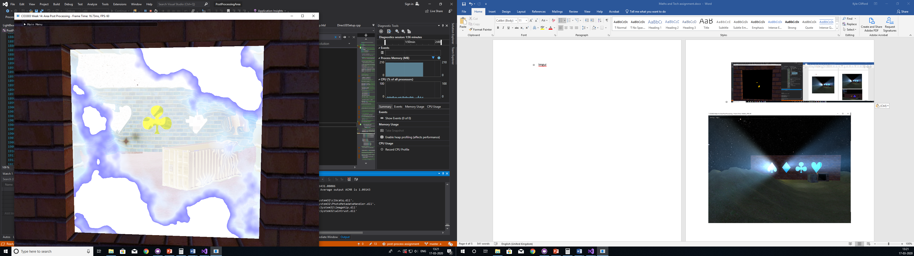
  + a